Aman Kumar  
Contact no. - +91 8130778884

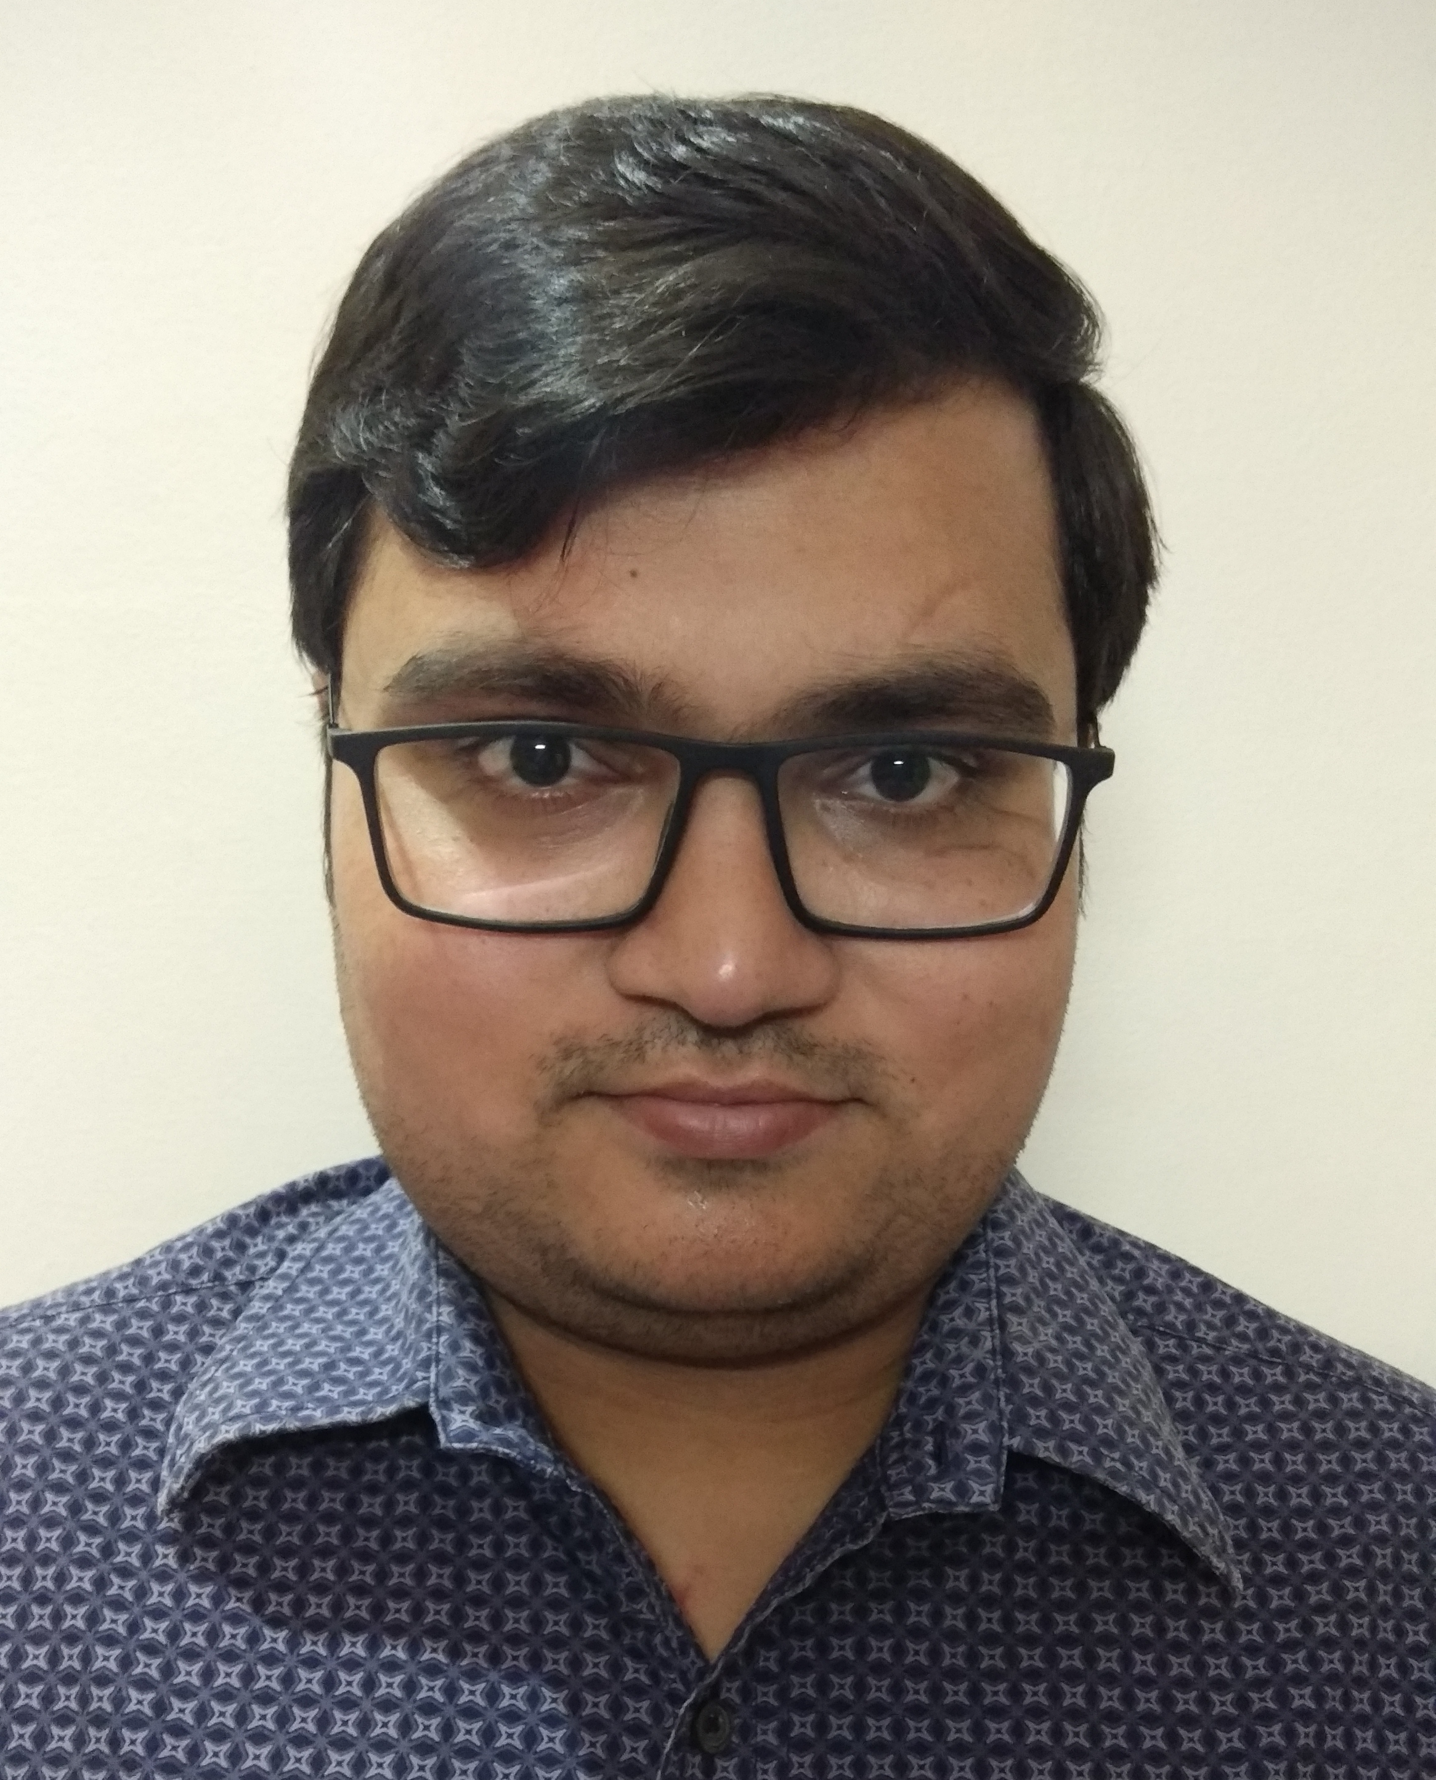

E-mail – [amankbhardwaj@gmail.com](mailto:amankbhardwaj@gmail.com)

**OBJECTIVE**

To make positive contribution as part of your dynamic and well reputed organization in a position where my management, decision making and communication skills will be appreciated and enhanced.  
  
  
- Ambitious, hard working, energetic and well disciplined.  
- Positive thinking, self-motivated and flexible  
- Good communication skills  
- Soft spoken  
- Good oral and written skills

**Personal Abilities**

**Working Experience**

- Working as a Business Associate with Unicorn from April 2018 to November 2018

- Worked as a Business Associate with ACE Management from Aug 2017 to Jan 2018.

**Education**

- Integrated BBA-MBA, Major Marketing, 1st Division from Mewar University

-12TH from NIOS   
- 10th from CBSE

**Academic Project**

- A study of Digital Marketing from KVCH IBM CE  
-Export Merchandising & Documentation from NIESBD

**Internship Program**

-New Development in Fertilizer Industry at Kanpur Fertilize and Cement Limited, Patna

-6 Months work in “**BEAN THERE” cafeteria as CRM Executive**   
  
-Sound Knowledge of Ms-Word, Ms- Excel, Ms-Power Point

**Computer Skills**

-Good Well experienced with use of internet  
  
- Participated in inter- departmental competitions  
- Participated in organizing cultural even in Mewar   
  
  
-Date of Birth : 03 Sep 1994  
-Languages : English, Hindi  
-Hobbies : Playing Cricket  
-Address : 5/969, MMS, Vasundhara, Ghaziabad, UP-201012,Ph:0120-4338884

**Extra Curricular Activities**

**Personal Details**